**Compass - Power of Attorney (POA)**

Power of Attorney (POA) Authorization

Mailing Addresses for a POA Authorization Form

Viewing POA Authorizations on File in Compass

Information Needed to Include with a POA Add or Revoke (Remove) Request

Turn Around Time

Related Documents

**Description:**  How to add and revoke a Power of Attorney (**POA**) Authorization form on file with us and how to determine the authorized agent’s name for the Power of Attorney and when the Authorization becomes invalid.

|  |
| --- |
| Power of Attorney (POA) Authorization |

Refer to the table below:

|  |  |  |
| --- | --- | --- |
| **Timeframe Valid** | **Authorization** | |
| Valid until authorization is revoked or beneficiary is deceased. | Power of Attorney is a legal document, which authorizes the designated individual to manage **all** aspects of a beneficiary’s account. This form should be suggested in instances when the beneficiary feels a representative should have access to unlimited Protected Health Information (**PHI**) and authorization to make changes to the account, such as address and payment changes.    The POA can be used:   * Disclosure of PHI/**PII** (Personally Identifiable Information) * Authorization to make account changes, including enrollment and disenrollment requests * Grievances * Coverage determination/appeals     The POA must meet the regulations set by the state in which the beneficiary lives.    POA is no longer valid upon the death of the beneficiary. To address any issues on the account for a deceased beneficiary, CVS Caremark must receive one of the following (copies are acceptable):   * Letters of Testamentary * Executor of Estate * Death Certificate and affidavit stating no one else is in line for their estate     **Notes:**   * POA forms are not available from CVS Caremark as legal requirements vary by state. * If a POA is denied, the beneficiary will be sent a denial letter along with the original POA. * Member may have multiple POA’s.     There are 4 different types of POA: | |
| **POA Type** | **Details** |
| POAD (Durable) | Names a designated individual to handle **all** of a beneficiary’s affairs. |
| POAF (Financial) | This allows the designated individual to handle **any and all**of the beneficiary’s **finances** (**Example:** Paying bills, opening bank accounts, applying for loan, etcetera). |
| POAG (General) | This is a non-specific POA that basically states: “I, the beneficiary, give the designated individual the powers to handle my affairs”. |
| POAM (Medical) | Allows the designated individual to make **any** changes to medical plans and make medical decisions for the beneficiary. |

Top of the Document

|  |
| --- |
| Mailing Addresses for a POA Authorization Form |

These addresses are used when adding or revoking (removing) a Power of Attorney Authorization from the member’s account. Allowing custodial parents, legal guardians, etcetera to speak on the member’s behalf.

Do not instruct the member to fax or mail information directly to the call center.



**Documentation must be sent to the below addresses:**

|  |  |  |
| --- | --- | --- |
| **Commercial members** | **Medicare D members** | **Urgent** |
| <PBM Name>  PO BOX 6590  Lee’s Summit, MO 64064-6590  Refer to [Compass - Forms Members Can Submit to Authorize Access and Release of Information for Their Account (053891)](https://thesource.cvshealth.com/nuxeo/thesource/#!/view?docid=91b652db-c5b2-4769-b300-e1e2c95ec009). | **Medicare D members, including SilverScript, Blue MedicareRx, EGWP/HealthPlan:** Refer to [Compass MED D - Appointed Representative Form (AOR) or Power of Attorney (POA) (061884)](https://thesource.cvshealth.com/nuxeo/thesource/#!/view?docid=64c3fc62-48c3-4ad3-ae83-c736cebd521b) for addresses and other information. | For urgent situations in which the member needs to send the information via Express shipping requiring a physical address, provide the address below:  Research Team  800 NW Chipman RD Suite #5830  Lee’s Summit, MO 64063  **Note:**  Mailing via Express shipping only gets the form to us faster, but due to the amount of mail we get, the TAT is still up to 10 business days. If a member is asking for us to expedite the processing, call Senior Team to submit Inquiry Task to attempt to speed up processed but advise member it is not guaranteed to work. |

**Note:** In the event that a POA Authorization form or other legal documents are received in the call center, forwarded them using interoffice mailto one of the above addresses.

Top of the Document

|  |
| --- |
| Viewing POA Authorizations on File in Compass |

To view existing POA authorizations on file, navigate to the **Quick Actions Panel** and select **Privacy Records**. Refer to the **Viewing Authorizations on File in Compass** section of [Compass - Forms Members Can Submit to Authorize Access and Release of Information for Their Account (053891)](https://thesource.cvshealth.com/nuxeo/thesource/#!/view?docid=91b652db-c5b2-4769-b300-e1e2c95ec009).

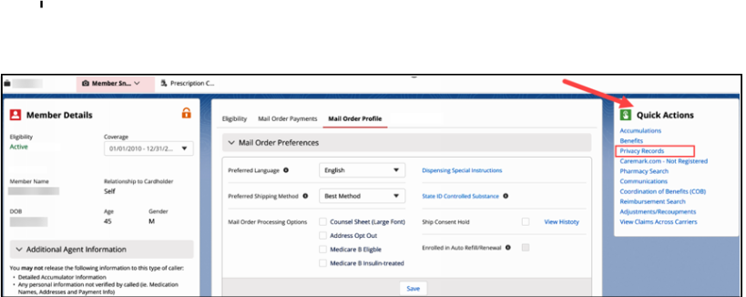

**Note:** If a valid Power of Attorney authorization is on file on a member’s **expired account**, create a Support Task, **Task Type:** Account Executive Consideration. Refer to [Compass - Support Task Types and Uses List (058147)](https://thesource.cvshealth.com/nuxeo/thesource/#!/view?docid=6753488f-3996-45d9-88ba-257575369a98) for additional information.

Top of the Document

|  |
| --- |
| Information Needed to Include with a POA Add or Revoke (Remove) Request |

**MED D Beneficiary:** Refer to Compass MED D - Appointed Representative Form (AOR) or Power of Attorney (POA) (061884).

* The original Power of Attorney documents are only returned if a note is included requesting this action.
* When there are two POA documents on file and both are added on the account; the second POA document must be entered and marked as termed with the next day's date and then coded as: DFRP(Default Responsible Person).

Inform the member that the below information must be gathered and mailed to <Pharmacy Benefit Manager (PBM) name>:

* Plan Member’s full name
* Plan Member’s ID Number (exactly as shown in our system)
* Plan Member’s Date of Birth
* Plan Member’s Address/Telephone Number
* Copy of the existing Power of Attorney document that indicates the name, address, and telephone number, of the person(s) authorized to act on behalf of the member
* Copies of any other documents that are referenced in the POA document (if applicable)
* Provide mailing address, refer to Mailing Addresses section above.

## 

**Result:** Once the documentation has been received, evaluated and if approved, the Power of Attorney is documented in Compass. Refer to the Viewing POA Authorizations on File in Compass section above.

Top of the Document

|  |
| --- |
| Turn Around Time |

Up to 10 business days from the time that the Research team receives all the properly completed documentation.

Top of the Document

|  |
| --- |
| Related Documents |

**Parent Document:** [CALL-0011 Authenticating Callers](https://policy.corp.cvscaremark.com/pnp/faces/DocRenderer?documentId=CALL-0011)

[Compass - Guided Caller Authentication (050163)](https://thesource.cvshealth.com/nuxeo/thesource/#!/view?docid=80476f74-7dca-4548-bf35-185ca8d45c13)

[Compass - Forms Members Can Submit to Authorize Access and Release of Information for Their Account (053891)](https://thesource.cvshealth.com/nuxeo/thesource/" \l "!/view?docid=91b652db-c5b2-4769-b300-e1e2c95ec009)

[Customer Care Abbreviations, Definitions, and Terms Index (017428)](https://thesource.cvshealth.com/nuxeo/thesource/#!/view?docid=c1f1028b-e42c-4b4f-a4cf-cc0b42c91606)

Top of the Document

Not to Be Reproduced or Disclosed to Others without Prior Written Approval

**ELECTRONIC DATA = OFFICIAL VERSION / PAPER COPY = INFORMATIONAL ONLY**